**Design and deployment of wordpress website with ec2 and mysql**

**Introduction:-**

WordPress is a highly popular content management system (CMS) that is used for over 30% of all sites on the internet. It is most commonly used for blogs but can also be used for running e-commerce sites, message boards, and many other popular use cases.

Using this project we can set up a WordPress site to run a blog. WordPress requires a MySQL database to store its data. For this lab, you will use Amazon RDS for MySQL to run your MySQL database**.**

**Services used:-**

a) Amazon RDS

b) Amazon Ec2

c) webbrowser

**Working principle:-**

**Steps1:-**

Create AWS account and login.

**Step2:-**Create Security group.

1. In search bar search VPC.

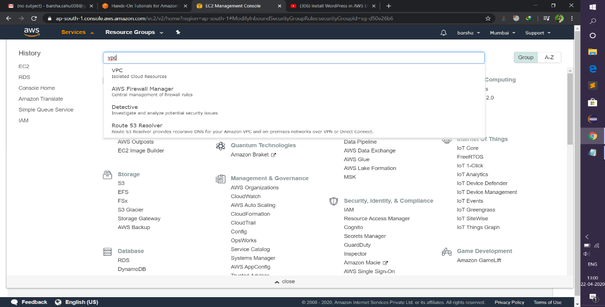

b) click Lunch vpc wizard. We have to create 2 security group,1 for ec2 and another one for rds.

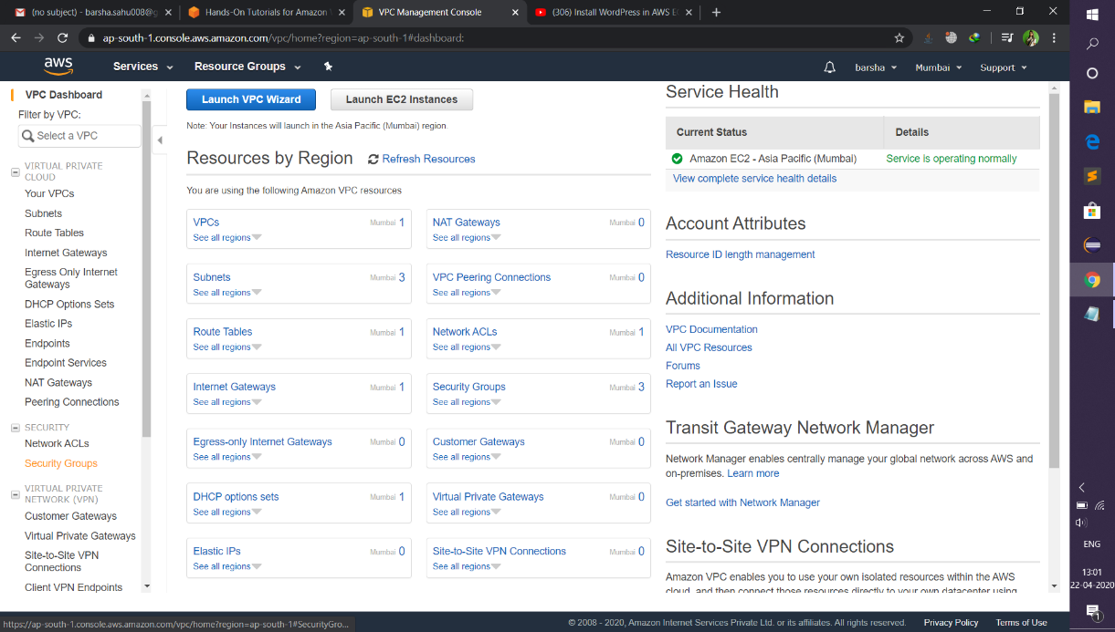

c) click Create security group then give security group name.

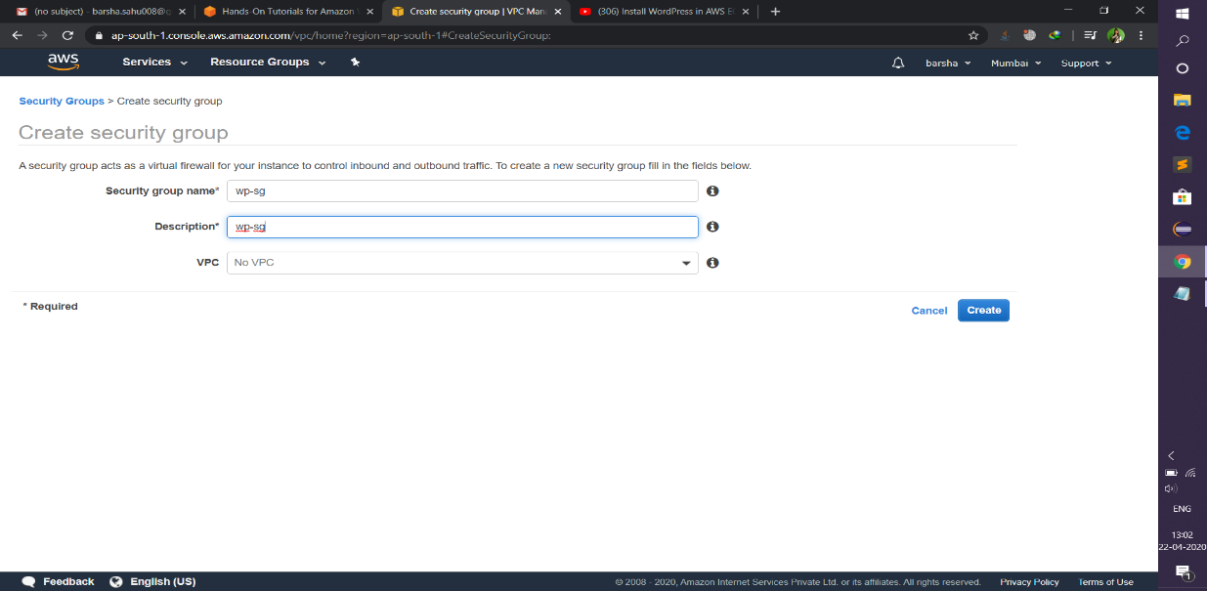

->Then click create .In the dashboard display the security group .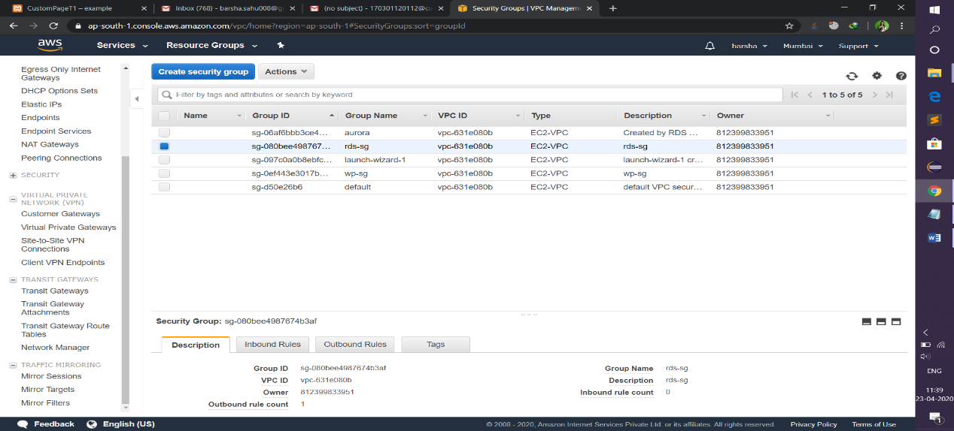

d) For ec2 security group , add inbound rule SSH and HTTP and choose source anywhere.

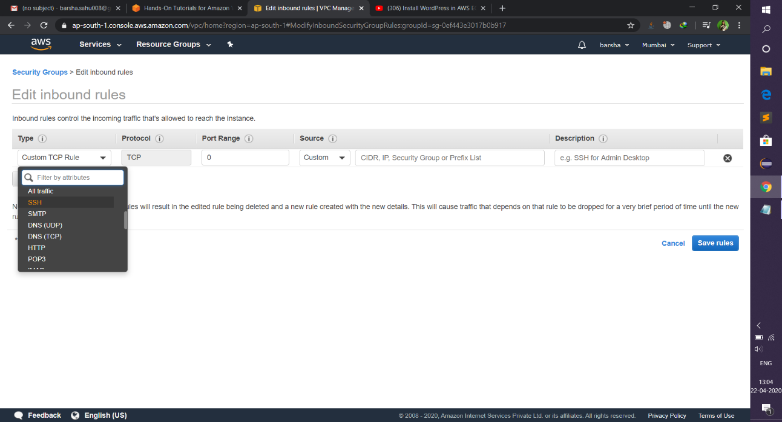

e) For RDS security group add inbound rule add mysql/aurora then in the security group field add ec2 security group.

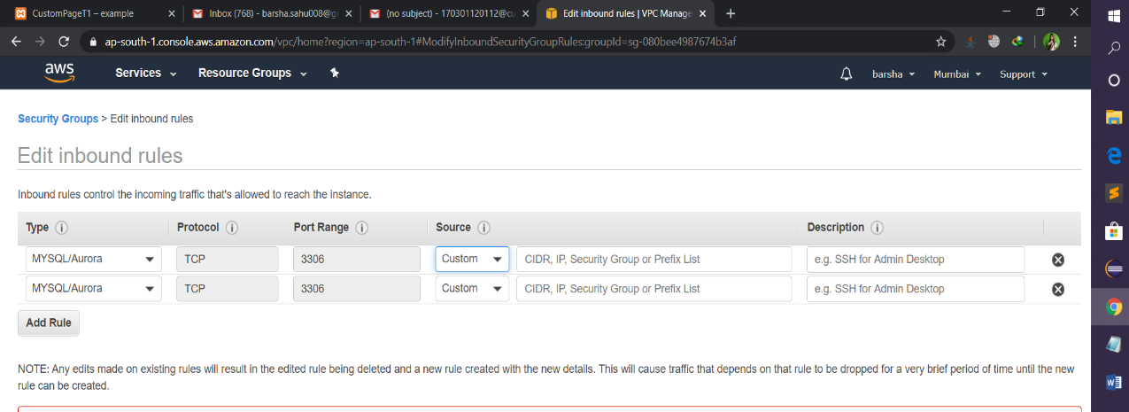

e) click save rules.

**Step3:-** Create your MySQL database

1. Go to Amazon RDS in the AWS console. Click the orange Create database button to get started.

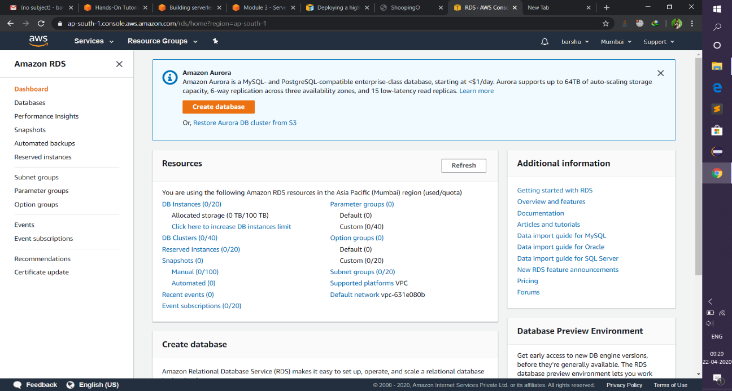

1. In the engine option choose Mysql and template option choose Free tier.

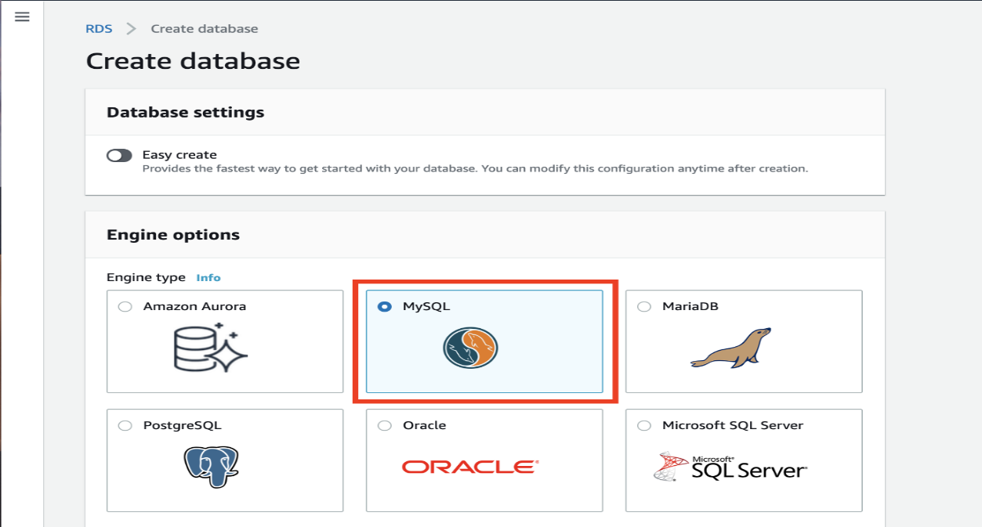

1. In the settings option give database in the database name field and give master password and confirm password.

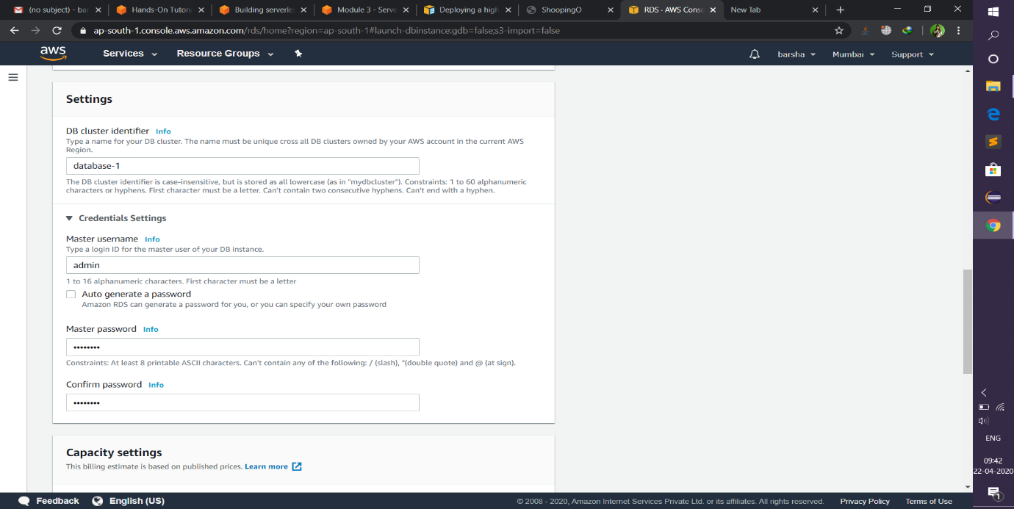

1. In the additional setting give the initial database name and leave all the fields, then click create database.

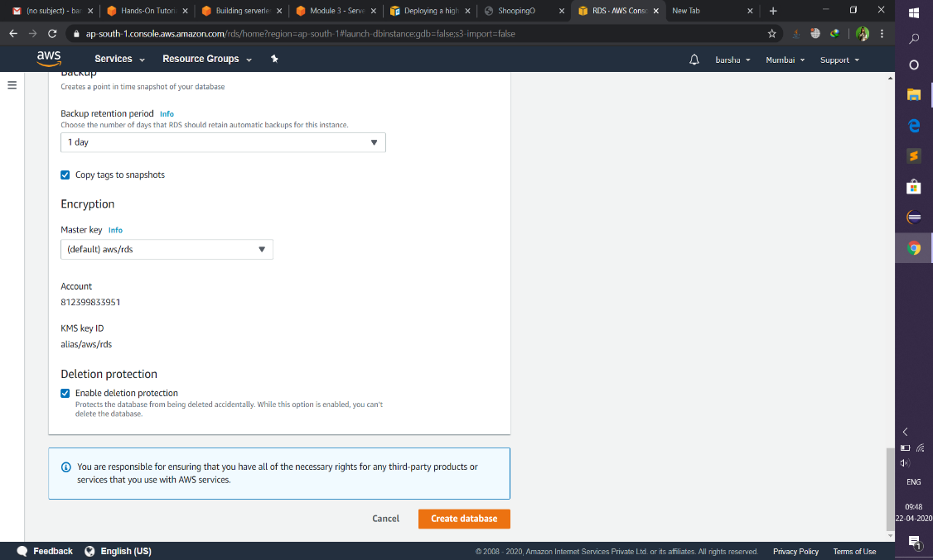

1. We can see the success notice indicating that the database is being created.

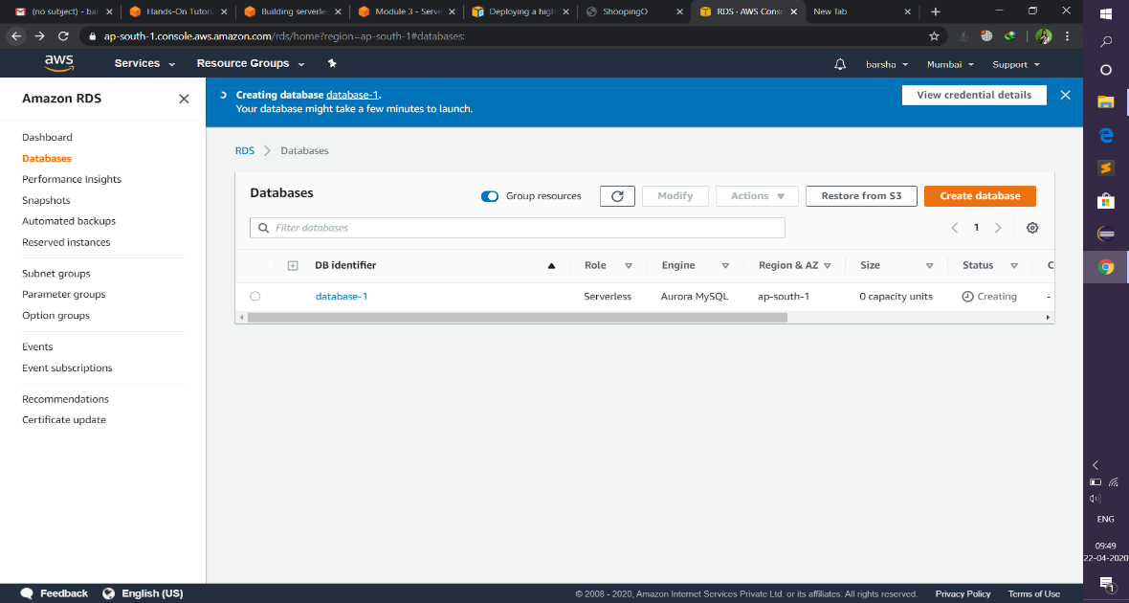

f)click on the database name and copy the end point of the database for further use.

**Step4:-**Creating Ec2 instance.

1. Click the blue button that says Launch instance to open the instance creation wizard.

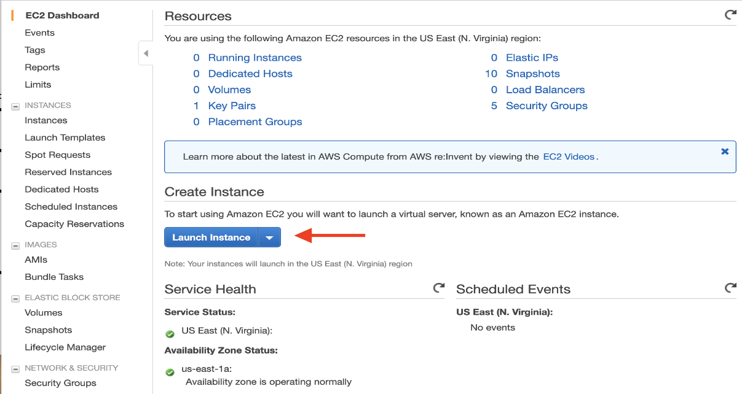

1. Then choose Amazon Linux 2 AMI , then choose general purpose which is free tier. 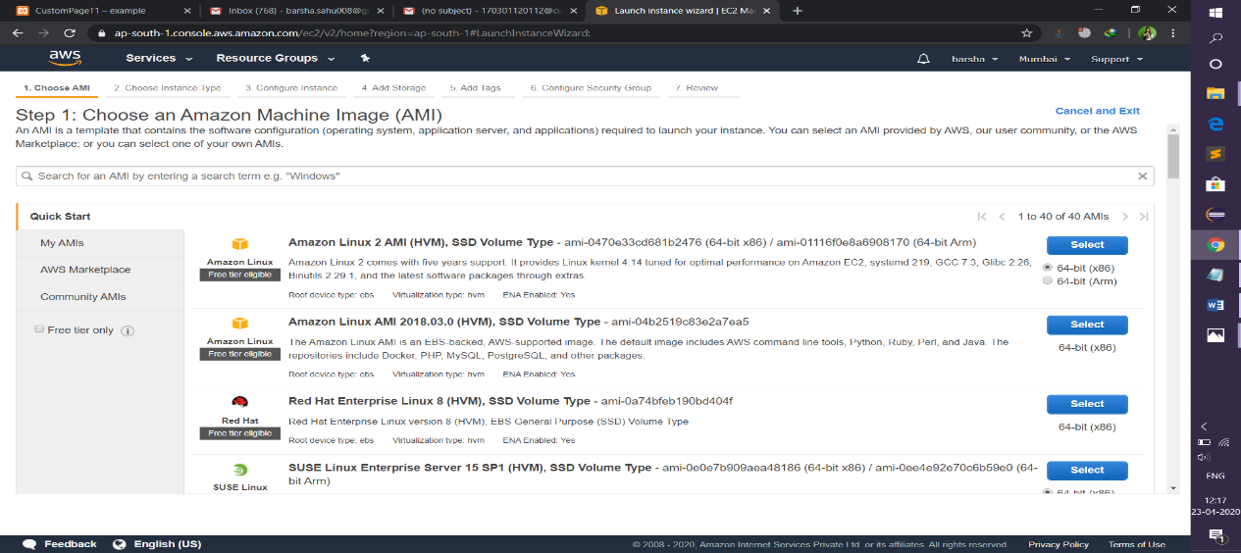

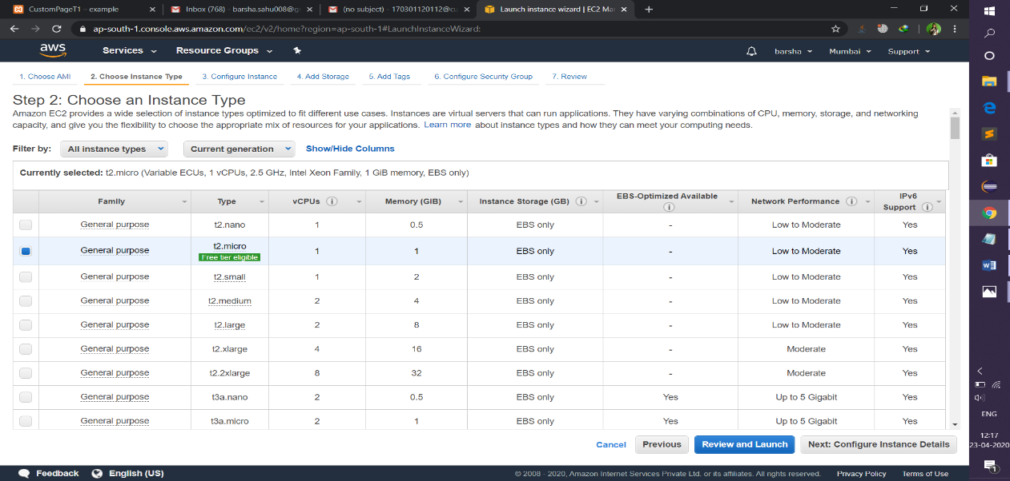

1. In the advance details copy and paste the below in the description box.

#!/bin/bash

yum install httpd php php-mysql –y //install php mysql

cd /var/www/html

wget <https://wordpress.org/wordpress-5.1.1.tar.gz> //download wordpress

tar -xzf wordpress-5.1.1.tar.gz //Extract file

cp -r wordpress/* /var/www/html/ //copy the extract wordpress file to the html

directory

rm -rf wordpress //remove wordpress

rm -rf wordpress-5.1.1.tar.gz //remove zip file

chmod -R 755 wp-content //set permission for wp content folder

chown -R apache:apache wp-content

service httpd start

chkconfig httpd on

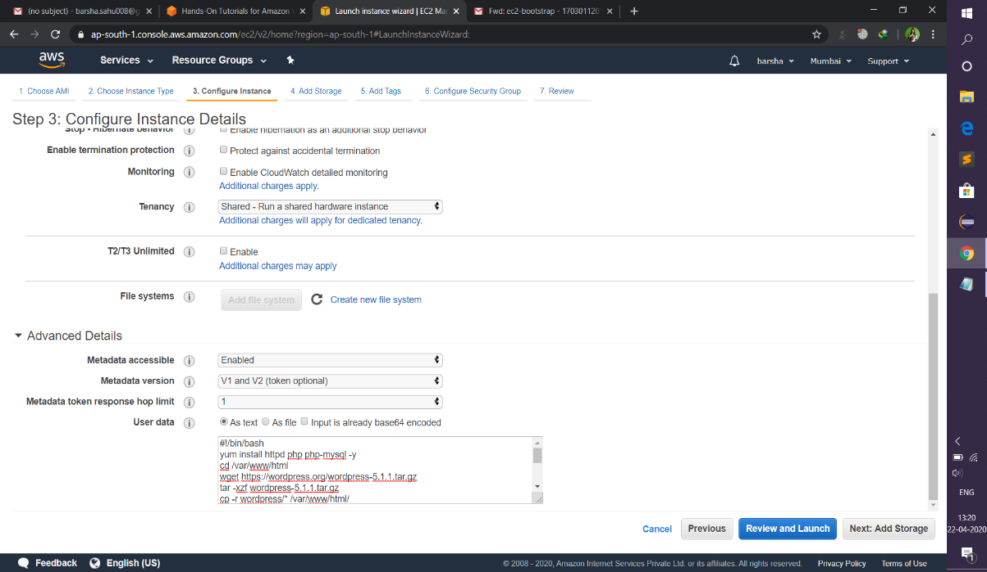

d)In the Configuration security group choose existing security group then choose the ec2 security group which is created earlier.

e)Then click lunch instance button. After that it give successful message.

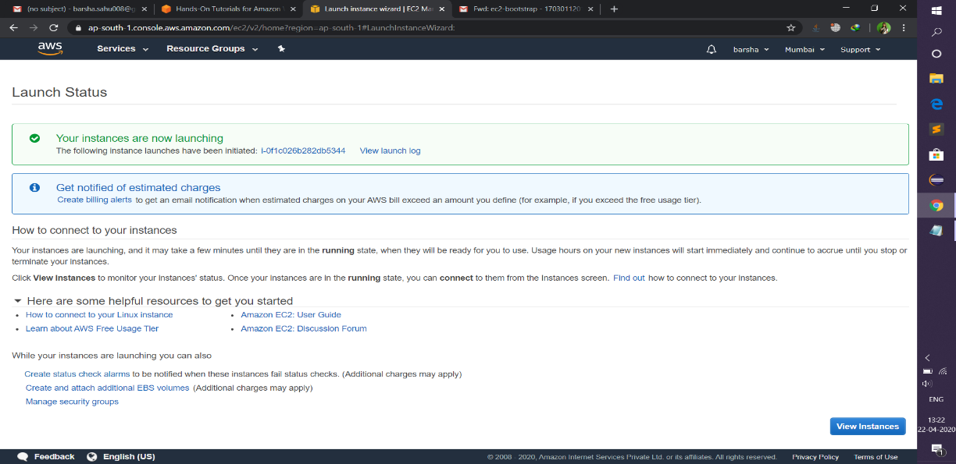

**Step5:-Configuring Wordpress on Ec2.**

1. Copy the public DNS of the instance.
2. Login the virtual server using putty.

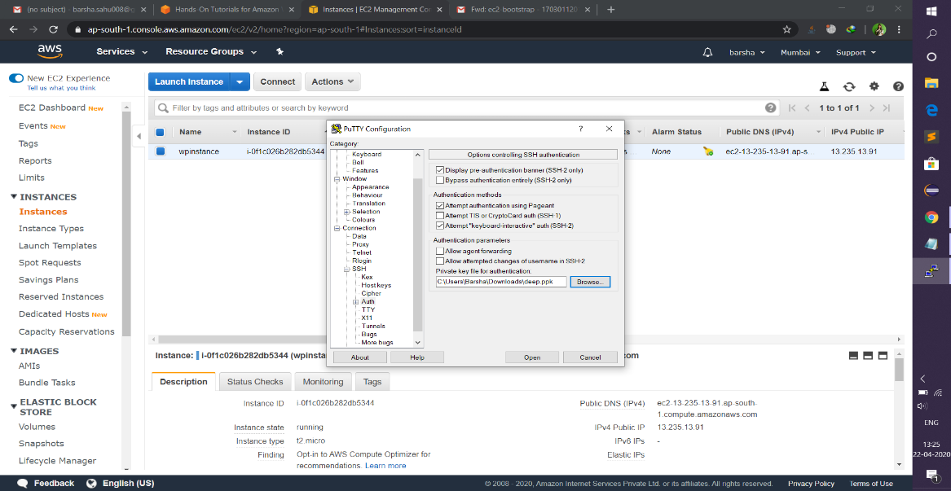

1. Then type the following command:-

Sudo su

Ls

Cd/var/www/html

Ls (Here the wordpress folder is displayed)

service httpd start

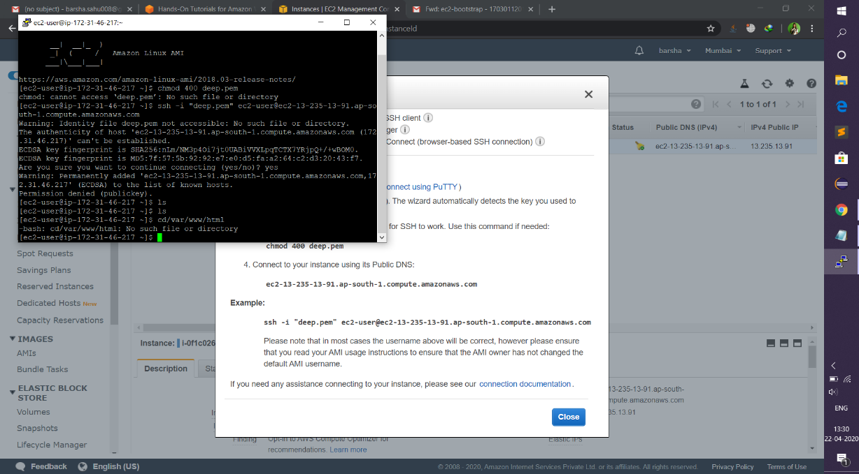

1. Copy the public id then paste in the browser.

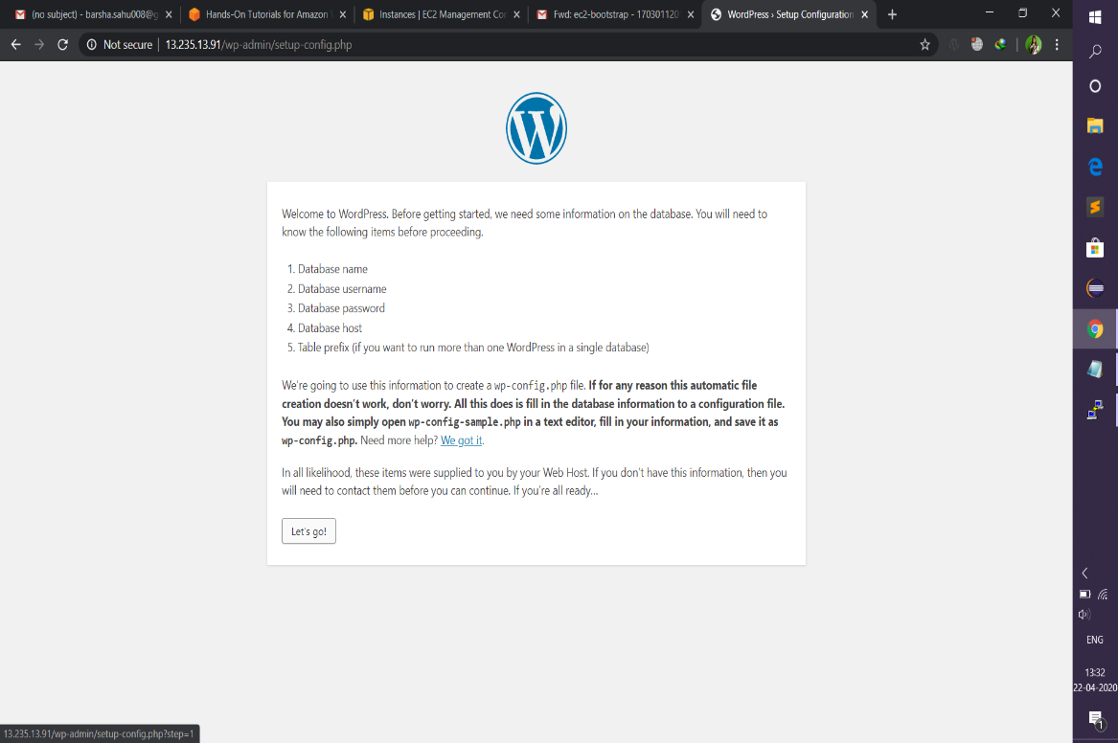

1. click lets go give database name ,username ,password, database host(end point of the database) then leave table prefix then click submit.

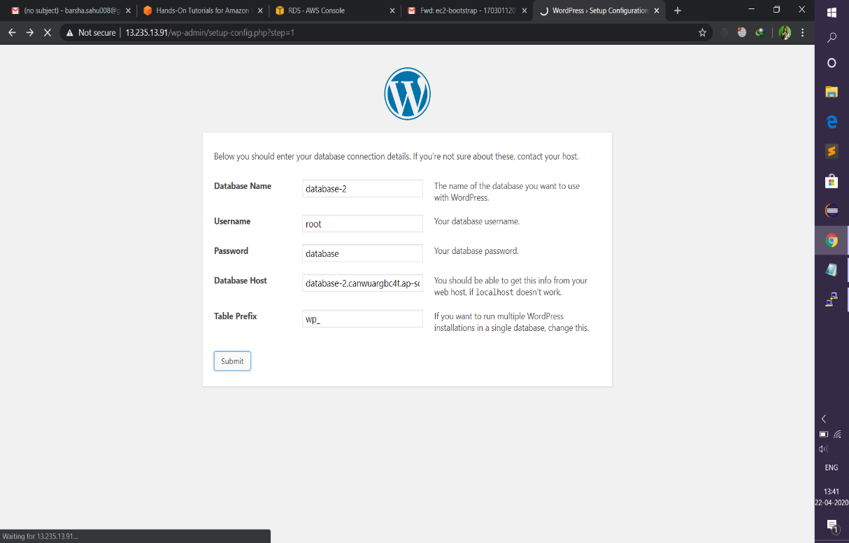

1. After submission copy the code and create a wp-config.php page in the terminal then paste the code in this file.
2. Fill up all the fields then click install wordpress.

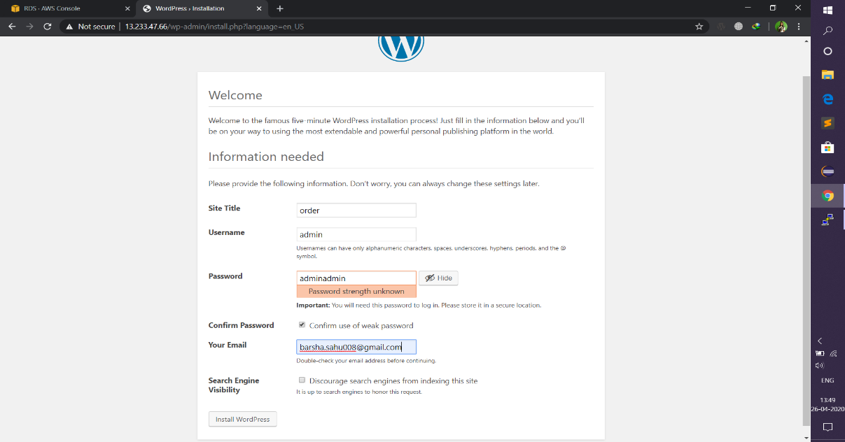

1. It gives a successful message.

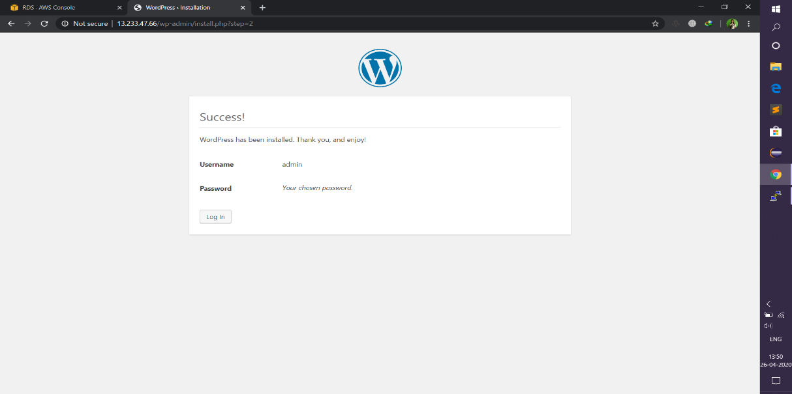

1. Login wordpress with giving username and password.

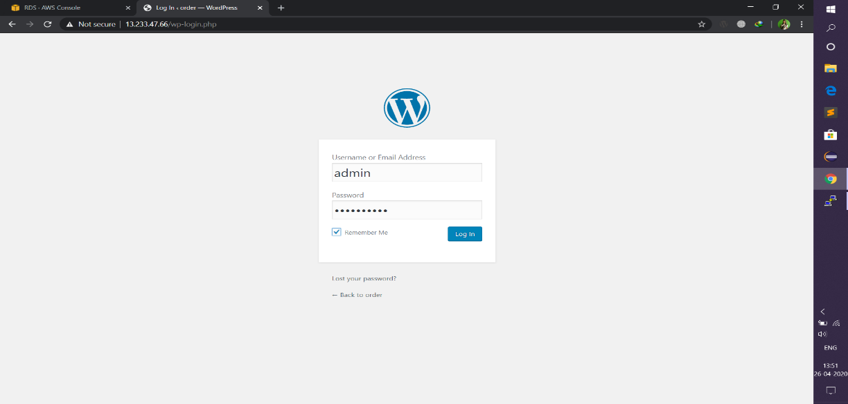

J) Dashboard of the wordpress.

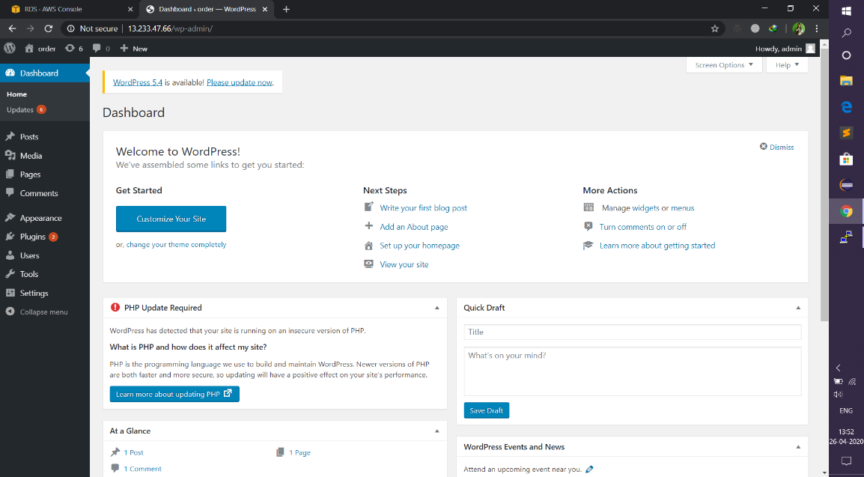

H) We can customize websites in wordpress.

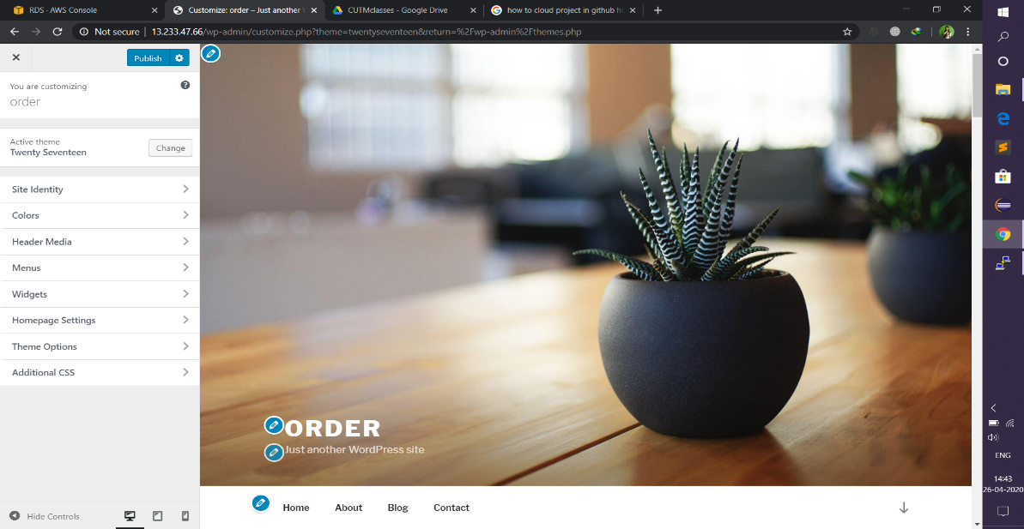

K) We can also perform some mysql operations ,within that we can know the database name ,username ,login date in our terminal.

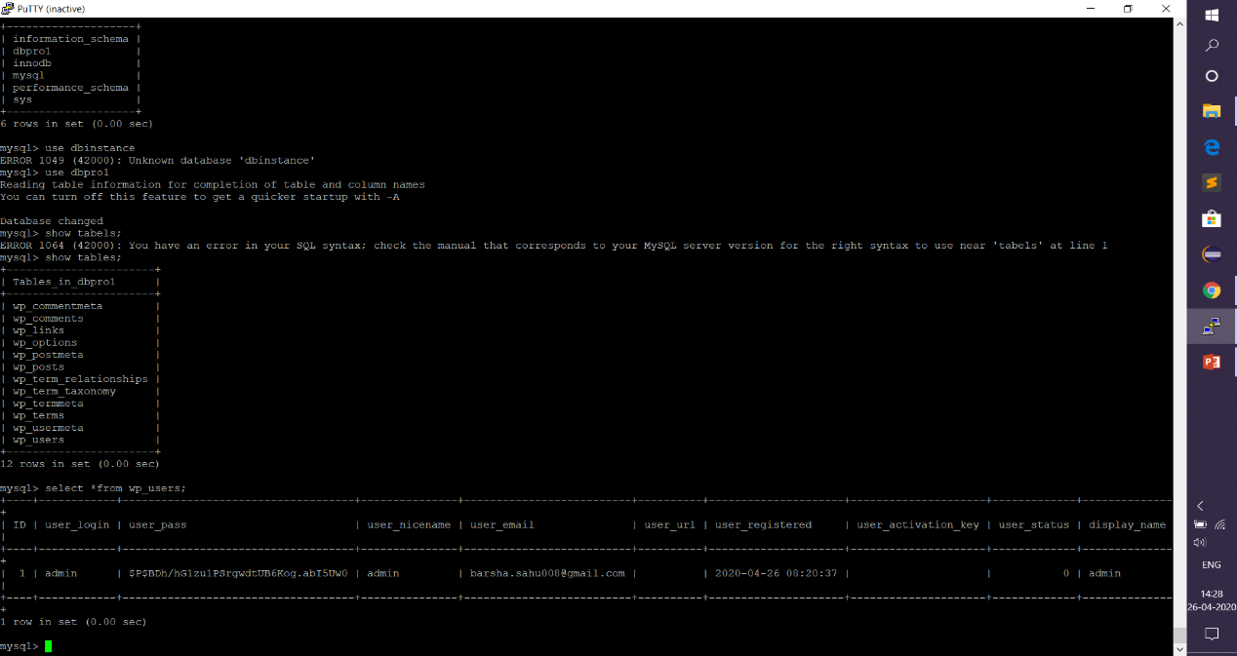

Barsha Sahu

170301120112